CHAPTER SIXTEEN

THE GUITAR REIMAGINED

MARC ESTIBEIRO and DAVID COTTER

Introduction

Performers and instrument designers have been exploring ways in which to expand the possibilities of the guitar through electronics since at least the 1930s. The history of the classical guitar and electronics, however, is much less familiar to a general audience. This is despite the fact that a great many innovative pieces that bring together the classical guitar and electronics in innovative and imaginative ways have been written, performed, and recorded by amateurs and professionals around the world. This chapter presents the contextual background for an integrated hybrid system for classical guitar and electronics, which exploits the guitarist’s existing skillset in order to control the electronic environment. As compositions for classical guitar and electronics have developed from the 1960s to the present day, and as new technologies have been adopted and incorporated, the relationships which exist between the performer, the acoustic instrument, the electronic elements, and the audience continue to highlight issues which arise whenever traditional acoustic instruments interact with electronics. Many of the questions raised are applicable in other situations where humans interact with technology. Such questions include: When we refer to musical instruments, what exactly are we referring to? Are electronic, hybrid, and acoustic instruments essentially different manifestations of the same phenomena, or are there fundamental differences? What is the relationship between the instrument and the performer? Is this relationship altered when electronic elements are introduced? Can the concept of virtuosity be applied to electronic instruments in ways similar to its application to acoustic instruments? And, more broadly: What is the musician’s relationship to technology and does this relationship reflect the uses of technology in society generally? The answers to these questions are used to inform the development of an integrated hybrid environment for the classical guitar and electronics.

What is a “musical instrument”?

The idea that music is a fundamentally human endeavour is deeply embedded in our understanding. Indeed, some form of human involvement is still very much a defining characteristic of all forms of music making. Even with autonomous generative systems, there is an assumption that a human being is, or has been, involved somewhere in the process. Closely connected to this, although perhaps less fundamental, is the idea that music is something which is, in some sense, “performed”. Tied into the concept of performance is the idea of the musical instrument. A common-sense view would be that musical instruments exist as discrete entities through which people perform music; instruments are the objects through which human beings realise music. But on closer examination this view turns out to be, at best, incomplete and naïve. The relationships that exist between performers, musical instruments, and the wider environment are more subtle and elusive than they at first appear. The ways in which these relationships are conceptualised have implications, not only in terms of instrument design but also in terms of approaches to composition, improvisation, performance, and listening. That is to say, there are implicit assumptions regarding instruments that are embedded in every stage of the musical process, which influence the various creative processes.
Perhaps the first way in which the common-sense view of a musical instrument is found to be lacking is in the idea that a musical instrument is a discrete object; a “self-subsisting material object, intentionally crafted for the purposes of making music by performing musicians” (Alperson, 2008). In other words, at the risk of sounding facetious, we all know a guitar when we see one. The six-string classical guitar can be specified as a composite chordophone, sounded by the bare fingers or fingernails, with the Hornbostel–Sachs classification number 321.322–5.31 (Hornbostel & Sachs, 1961) (MIMO Consortium, 2011). Generally, it has a wooden hourglass-shaped body (comprising varieties such as cedar, cocobolo, Hawaiian koa, mahogany, maple, rosewood, and/or sapele) with six strings (three nylon, and three steel-wound nylon). Often confused with the acoustic guitar (which, generally, can be identified by its dreadnought-shaped body, six steel strings, and Hornbostel–Sachs classification number 321.322), the boundaries differentiating various types of guitar have become increasingly blurred in recent decades. The relationship between the instrument and the performer is, however, quite subtle and, in many cases, it can be hard to tell exactly where the body of the instrument ends and that of the performer begins. An obvious example would be a singer, where the body of the performer is also the instrument. Singers work hard to develop and maintain their voices and, in many ways, do seem to identify their bodies as their instruments. Similar, if less extreme examples can be found with other instruments. The embouchure of a brass player is an essential component of the sound. The tone of a classical guitar depends not only on the player’s technique but also on the type, shape, and length of the player’s finger nails (Tennant, 1995). Guitarists have been noted for giving extraordinary attention to their nails (Dawe, 2010). It is clear, therefore, that the relationship between a player and an instrument is an extremely intimate one. When considered in this way, the point at which the instrument ends and the player begins blurs into a continuum. The point is that physical aspects of the player’s body can be as responsible for the sound of the instrument as any attributes of the instrument itself. Whether any aspects of this physical continuity between player and instrument remain when electronic elements are introduced will depend on both the interface used to access the engine of the instrument and the way in which the interface is mapped. The principal difference is that any gesture/sound relationship will be an arbitrary mapping imposed by the instrument designer rather than a direct physical connection, as is the case with an acoustic instrument.
Of course, musical instruments are more than material objects. They are also tools which we imbue with our aesthetic values and choices, belief systems, scientific understandings, and many other aspects of the human experience (ibid.). This is easy to see with electronic instruments. Audio and computer hardware, programming languages, code written for specific purposes, human-computer interfaces, etc. are all infused with concepts and information built upon histories of mathematics, acoustics, computer science, composition, and all the other disciples, practices, and assumptions which affect the creation of such systems. It is equally true of acoustic instruments: they are “culturally conditioned objects” (Alperson, 2008).
The instruments which are available to us in our society are the result of historically and culturally informed choices that are often driven by economic factors, emerging technologies, shifting aesthetics, and social structures, etc. Performers and composers in all fields of music have always tested and expanded the affordances of available instruments, and instrument designers have responded by working to satisfy those needs. Any advances in instrument design can in turn influence the creative decisions of the practitioners. For example, the cyclical relationship between composition and instrument development has been labelled as “composition changing instruments changing composition” (Redgate, 2017). Tuning systems, value judgements as to what constitutes a beautiful, harsh, or ugly sound, attitudes towards technique, and performance practices are all embedded in our instruments. We will continue to embed such values into our musical tools as we expand our range of available instruments through technology and as different communities of users adopt and develop those instruments to reflect their values and to meet their needs. Even the most “experimental” of music, for example, reflects a decision taken as to whether or not the experiment was worth conducting in the first place.

How do instruments evolve?

When humans interact with technology, the ways in which the technologies can develop are suggested by the different uses which are found for existing systems: what the philosopher Don Ihde calls “multistable variations” which can lead to further or different developments (Ihde, 2007). However, new technologies are not always welcome because users of the existing technologies may have invested considerable effort and time into acquiring the skillsets necessary to work with the existing technologies. There is a reluctance to abandon existing practices simply to accommodate new modifications. As we will discuss in a later section, this is one of the main problems of digital instruments with novel interfaces which may only be used for a small number of performances. An example from the history of instrument design which illustrates this point is the sustaining mechanism on a piano. The original mechanism was initially a hand-controlled stop. Some early pianos had two stops, one for the bass strings and one for the higher strings. The impracticality of operating the stop while playing, however, led to the development of knee levers. The modern solution of pedals, which seems so common-sensical, inevitable even, from our perspective, and such an integral part of both the instrument and the performance practice, did not emerge until around 1772. Even then, pedals were not initially widely adapted and pianos continued to be manufactured with stops and knee levers for decades (Good, 2002).
Another, more recent, example of Don Ihde’s multistable variations, where the instrument develops in ways which were not anticipated by the original designers, is the Roland TR-808 drum machine. This was originally developed as a tool intended to help musicians create demos of their work (Roland, 2020). At a time when memory chips, capable of storing samples of real drum sounds, were too expensive for the target market, Roland created an instrument which instead used analogue circuitry to approximate the sounds of an acoustic drum kit. The design incorporated an out-of-specification transistor, the 2SC828-R, which gave the drum machine a highly distinctive and somewhat “unnatural” sound, which is described by Roland as “sizzling” (ibid.). The product itself was a commercial failure for Roland and was discontinued in 1983, having sold fewer than 12,000 units. The release of the much more “realistic” competitor Linn Drum in 1982, a product which did incorporate sampled drum sounds, was another factor that led to the early withdrawal of the instrument. However, from the mid 1980s onwards, the TR-808 was adopted by musicians working outside mainstream trends, particularly in the emerging electronic dance music and hip-hop scenes and has since become one of the most influential and ubiquitous sounds of contemporary popular music. The sounds of the instrument have been widely copied and the step-sequencer interface has been emulated and adapted in a great number of hardware and software environments. The Roland TR-808 is a powerful example of an instrument which was developed to meet the needs of one community of users but was subsequently adopted and subverted by a different community in ways which were unforeseen by the instrument developers and which have led to further innovations. Features which were initially perceived as weaknesses: the artificiality of the sound, the rigidness of the output, and the step-sequencer interface, in a different context were seen as strengths which led to further innovations and developments.
It is clear, therefore, that our musical instruments both reflect and influence the ways in which we understand, value, and practice music. It is also clear that the relationship between designers and practitioners is a cyclic and developing process. Practitioners of music, not only the composers and performers, but also audiences, promoters, and any other interest group invested in the process, use instruments in unforeseen ways or make demands which the instruments are unable to meet in their current forms. Instrument designers then respond to these demands and the process is repeated. It is important to note, of course, that there is a great deal of intersectionality between the different user groups.
Having explored, briefly, what we mean when we talk about musical instruments, it would now be instructive to consider the ways in which we relate to, and make use of, those instruments. The ways in which societies use tools more generally to interact with environments, as well as how they gain the necessary skillsets for using those tools are useful areas to explore here. From this we can consider skills acquisition in the context of musical virtuosity and examine whether the concept of virtuosity makes sense in the context of digital instruments and how digital instruments may differ more generally from acoustic instruments.

What is the relationship between the instrument and the performer?

As a generalisation, and with a great many exceptions, it seems that there is a perception that people, or at least those of us who are not invested in the area of new music as practitioners or listeners, tend to be innately suspicious of bespoke electronic instruments. In some sense they are not “real” instruments. Those who perform on electronic instruments, perhaps with the exception of instruments whose interfaces are modelled on acoustic instruments, are not “real” musicians. The steadily growing popularity of electronic dance music and DJ culture over the last few decades is slowly challenging this image but the stereotype persists, at least in a live context, of the computer musician sitting on a stage behind a laptop checking emails. Even the language used to describe certain genres associated with electronic instruments–sonic art, sound art, “experimental” music, etc., suggests that there is something suspect about this work. The extent to which these prejudices linger may be due, at least in part, to our ideas of virtuosity and what it means to be a musician.
Don Ihde describes the act of making music on an acoustic instrument as a relational phenomenon involving intentionality. It is an “actional intentionality which is directed, mediated through an instrument–a technology” (Ihde, 2007). This intentionality involves human embodiment actions: music is created through the enacting of embodiment skills mediated through instruments. Furthermore, as performers become increasingly proficient on their instruments, there is a sense in which the instruments become more transparent and the resulting music becomes progressively more satisfying. His idea, shared by many musicians and non-musicians, that, as a performer develops a skillset, the instrument “disappears” and becomes, in a sense, an extension of the performer’s body, would seem to have at least some basis in reality.
There is a circular causality between ourselves and our environments. We act upon the environment and the environment, in turn, acts upon us with our technologies acting not simply as mediators but as agents which change our understanding of the world and consequently lead us to new affordances. This has wider, societal implications. New instruments–acoustic, electronic, or hybrid–and new performance practices do not only lead to new sounds and new genres, but they also change the ways in which we relate to those sounds. In other words, what we accept as music, how we define musicians, how we create music, and how we consume our music are changed, as are our attitudes to arts funding, music education, music consumption, live performance, and so on.
If we view musical instruments, therefore, as technologies through which we reframe our understanding of the world, then the ways in which we develop competencies on those instruments, and, perhaps just as importantly, our attitudes to those processes, will also have important consequences. Returning to the idea that a musical instrument seems to “disappear” in the hands of a skilled performer, it would be instructive to examine in more detail exactly how this may occur. In a lecture delivered at Radboud University and available online, the post-phenomenologist Peter-Paul Verbeek describes Martin Heidegger’s distinction between two ways in which tools can be made available for human beings (Radbound Reflects, 2018). Tools can be “to hand” or “at hand”: a hammer used to hit a nail is “to hand” in that the user’s attention is focused on the task–hitting the nail–rather than the tool–the hammer. When learning to drive a car, however, the user’s attention is very much on the controls of the vehicle, which are “at hand”: the tools demand attention for themselves. As the learner driver increases in confidence, however, focus gradually shifts to the road and the controls consequently become “to hand”: they become part of the user’s relation to the world.
Expanding on this idea of tools as mediators, Verbeek describes Don Ihde’s four ways in which technologies can mediate human-world relations: in an embodiment relationship the human combines with the technology to experience the world–we look through a pair of glasses rather than at a pair of glasses, to use Verbeek’s example. We have already seen that performing on an acoustic instrument is another example of an embodiment relationship. A technology which shows you a representation of the world, which you then have to interpret, such as reading the temperature of a thermometer, is an example of a hermeneutic relationship. In the context of digital instruments, any interface which presents data to the performer–amplitude thresholds, pitch tracking, visual cues, etc., would form part of a hermeneutic relationship. An alterity relationship is one in which humans interact with technologies with the world in the background: getting money from an automatic cash machine is an example. Interacting with a user interface on a digital instrument could also fall into this category. The final category is the background relationship, in which technologies provide the context for human experience. Mechanical background noises or climate control systems are examples. The ambience of a concert hall, where our focus is on the event rather than on the room, would also fit into this category. As we saw earlier, tools and instruments do not have fixed uses, but are interpreted in different ways depending on broader contexts–multistability in Ihde’s terminology. Furthermore, our world views are shaped by our methods of mediation. We are changed by the ways in which we interact with our instruments, so the ways in which those instruments are designed have important consequences. Tools and instruments are not simply the media through which humans perceive and interact with the environment.
As musicians develop performance practices, they are also internalising highly specific embodiment relationships. The necessary skillsets, and the awareness of the instrument, move from the conscious to the unconscious. Virtuosic performance is only possible through the development of a complex hierarchy of embedded sensory-motor skills. Indeed the “disappearing” of the instrument is a necessary condition for control of the instrument at this level (Nijs, 2017). Long-term musical training results in the changes in neuroplasticity necessary for the auditory and motor feedback and feedforward mechanisms required for dynamic and responsive performances. Musical performance, particularly virtuosic performance, is an especially demanding activity which requires the integration of timing, motor sequencing, and spatial organisation, necessary to control and respond to information relating to pitch, rhythm, dynamics, and timbre. The musician also needs to be responsive to unanticipated variations in the wider environment, such as changes in the physical space, acoustics, audience responses, and visual and auditory information from other performers etc. Neuroimaging techniques have revealed structural change in the brain that support the specialized cognitive abilities of trained musicians. These structural changes reflect the increased auditory and motor abilities of trained musicians when compared to non-musicians (Zatorre, Chen, & Penhune, 2007). They also reinforce the idea of the instrument “disappearing” as the instrument moves from an object “at hand” to an object “to hand” in the development of the embodiment relationship, or the “perceptual illusion of non-mediation” (Nijs, 2017) that allows the skilled performer to experience the instrument as an extension of the physical self.
The problem of virtuosity in the context of many digital instruments, particularly bespoke instruments created for a limited number of performances, is that there is no time or incentive for the musician to develop any real performance skills on the instrument. The perceptual illusion of non-mediation can never develop and the instrument/performer relationship never moves from “at hand” to “to hand”. The physical motor skills traditionally associated with instrumental dexterity as well as the cognitive skills necessary to truly understand and exploit the affordances of an environment simply do not develop in the majority of cases. The lack of a tradition or school of performance practices, together with the inevitably arbitrary nature of the mappings of control parameters to the sound engine, only confound this problem. There is little reason for a musician to invest the considerable time and effort needed to develop new skillsets for environments which will inevitably have limited uses. It would appear to be the case, therefore, that bespoke digital instruments tend to discourage virtuosity.
Arguably the most successful and enduring digital instruments have been those which have interfaces based on, or which in some way extend, the interfaces of traditional acoustic instruments. These instruments are successful because they appropriate pre-existing and well-established histories of performance practices and communities of users. Digital keyboards, MIDI guitars, drum pads, etc. are all widely used and accepted in a variety of contexts and genres. Even the more innovative controllers used by, for example, DJs and the electronic dance music community, tend, with a number of exceptions, to have evolved from paradigms developed in the 1970s, 1980s, and beyond. The interfaces tend to be modelled on turntables and other analogue equipment such as the Akai MPC (Akai, 2020) or the Roland TR808 (Roland, 2020) which we discussed earlier. There are of course many exceptions to this generalisation, and many hybrid interfaces which mix new paradigms with traditional models, such as Ableton’s Push (Ableton, 2020).
The challenge, then, for the modern digital instrument designer, is to create an instrument which is accessible to performers, intuitive to use, simple to learn, but which still has scope for the development of a deeper skillset which exploits the full potential of the environment and which encourages the type of embodiment relationships discussed above. One approach would be to develop an interface which exploits the existing skillset of the performer: to design and map the digital instrument interface in such a way as to be able to exploit at least some of the embedded virtuosity of the performer and redirect it towards the affordances of the new environment. In the history of electronic processing and the guitar, this has been the dominant approach adopted by the majority of instrument designers. The following section offers a brief overview of this history. What is apparent from this history is that the use of electronics to modify or extend the sound of the guitar, while continuing to exploit the traditional performance practices of the instrument, has been an extremely successful model across a variety of genres. Delay based effects, distortion, multitracking technologies, digital synthesis, and so on have all been used for many decades, often operated with foot controllers, while the essential performance interface of the instrument is largely unchanged. Where electronics are used in ways which do not simply modify or extend the sound of the instrument, that is to say where there is a more complicated relationship between the electronics and the guitar, or where the performer is required to engage with the electronic elements in ways which challenge traditional performance practices, the results have been more varied. This is discussed in the later section on the history of the classical guitar and electronics.

Electronic processing and the guitar

Signal processing devices, both analogue and digital, have been widely used by guitarists for many decades. The first commercially available guitar fitted with a purpose-built electromagnetic pick-up was developed by George Beauchamp in 1931. He marketed the product through the Electro String Company founded in partnership with Adolf Rickenbacker (Rickenbacker, 2020). In 1936, the Gibson company introduced the first of their “Electric Spanish” guitar range, the ES-150 (Ingram, 2006). Recordings made by Charlie Christian working with the Bennie Goodman Big Band between 1939 and 1941 were enormously influential in popularising the amplified guitar as a legitimate instrument (ibid.). Since then, guitarists, particularly those working in mainstream popular and jazz styles, have in general been extremely keen to engage with electronics and have been well served by innovators and manufacturers. In 1949, Les Paul was using an Ampex reel-to-reel tape recorder to record multiple takes of his guitar (Paul & Cochran, 2016). By the 1950s, guitarists such as Chet Atkins and Scotty Moore were using the Ray Butts Echo Sonic, a portable amplifier with a built-in tape delay, to make slap-back echo an integral part of the sound of early rock and roll, and country (Hunter, 2005). In Britain, the Watkins Copycat tape delay unit became a key component of the hugely influential guitar sound of The Shadows. The use of tape effects and other analogue processing techniques on the guitar was widespread by the end of the 1960s. Well-known examples from that decade include reversed tape (e.g. I’m Only Sleeping, The Beatles; Castles Made of Sand, Jimi Hendrix), experiments with spatialization (e.g. Axis Bold as Love, Jimi Hendrix), and filtering (e.g. wah-wah pedal on Tales of Brave Ulysses, Cream). Analogue processing techniques for guitarists continue to be widely developed and used up to the present day.
By the 1980s, the introduction of the MIDI protocol, as well as newly emerging digital technologies, resulted in the widespread availability of digital effects for guitarists (Anderton, n.d.). In fact, perhaps the first commercially available digital effects processor, the Eventide H910 Harmoniser, had been produced in 1974 (Hughes, 2014) (Eventide, n.d.). From the 1970s onwards, guitarists were also able to trigger synthesised sounds using a variety of technologies, including hexaphonic pickups outputting separate analogue signals for each guitar string, control voltage and gate systems, and pitch to MIDI convertors. The Roland GR500, one of the first commercially available guitar synthesisers, was introduced in 1977. Even before that, jazz guitarist John McLaughlin had been experimenting with a 360-Systems guitar controller to trigger Moog and Emu synthesisers (KVA, 2014). By the mid 1980s, McLaughlin was using a Roland G303 guitar controller and a New England Digital Synclavier as an important part of his sound. Another prominent guitarist using the Synclavier at this time was Pat Metheny (Little, 1985). The SynthAxe MIDI controller for guitarists was introduced in 1985 and was adopted by prominent guitarists such as Lee Ritenour and Allan Holdsworth (Astley Brown, 2015). In June 1986, Guitar Player magazine in the UK published a special issue focusing on guitar synthesisers and MIDI (Guitar Player, 1986). By the 1990s, physical modelling systems became available to guitarists with Roland’s VG8 V-Guitar system appearing in 1995 (Roland, 2018). Although issues of high cost, latency, and tracking were problematic on early guitar synthesis and modelling systems, they have continued to develop to the point where today they are much more affordable, have excellent tracking, and minimal latency.

Traditional acoustic instruments as models of sound production and control

Despite the enormous and ever-evolving range of processing devices and controllers available to the modern guitarist, it is interesting to note that in the majority of examples outlined above the guitar is being used as though it were a traditional acoustic instrument. With traditional acoustic instruments there is a direct mapping between the performance gesture and the resulting sound. Furthermore, the instruments themselves typically follow a standard model for sound production. Chadabe identifies three components of a traditional acoustic instrument: a controller, a sound generator, and a link connecting the controller to the sound generator (Chadabe, 2002). In an acoustic guitar the controller would be the string, the sound generator would be the main resonating body of the guitar, and the link would be the bridge of the guitar and the fret or nut connecting the string to the body. If we add the performer to this model, we see that there is a direct physical connection between the performance gesture used to excite the string, the acoustic energy resonating in the body of the guitar, and the resulting sound of the instrument. This direct physical relationship is shown in Fig. 16-1.

Fig. 16-1: The direct physical relationship between the performer, the controller and the sound generator for a classical guitar

We have seen that this model of a musical instrument is a deeply embedded cultural archetype and continues to persist into the age of electronic instruments, in which mappings can be arbitrary and there are no necessary physical, causal relationships between gesture and sound as shown in Fig. 16-2.

Fig. 16-2: The arbitrary nature of mappings in a digital instrument

As a generalisation then, and with a great many exceptions, the use of electronics with the guitar has more closely tended towards the model for acoustic instruments rather than the arbitrary mappings of digital instruments.

The classical guitar and electronics

Although, as we have seen, guitarists in the present day have access to a wide range of analogue and digital signal processors and controllers, the history of the use of electronics specifically for the classical guitar is, perhaps surprisingly, much less widely known. There have been many innovative works written for classical guitar which explore extended techniques, non-standard notations, new sonorities, etc. (e.g. Sequenza XI for Guitar (Berio, 1988), Salut für Caudwell (Lachenmann, 1977), Tellur (Murail, 1977), and Kurze Schatten II (Ferneyhough, 1989)). However, beyond a very loyal and growing community of interest (often with connections to academia or institutions such as IRCAM (Ircam, 2020)), very few works for classical guitar and electronics have achieved more mainstream success or recognition. Indeed, many sources which may be considered standard texts on the history of electronic music do not mention the guitar at all (e.g. (Manning, 2013) (Emmerson & Smalley, 2001)). This is despite the fact that works for the classical guitar and electronics date back to at least the late 1960s. Guerrero Santos Marques (2020) has identified 24 works written for guitar and electronics between 1968 and 1979, 48 works written in the 1980s, 64 works in the 1990s, 86 works in the 2000s, and 64 works written between 2010 and 2018. (Sheer Pluck, n.d.), an online database of contemporary guitar music, currently suggests 324 pieces which include the acoustic guitar and electronics, and nearly 1,000 pieces once the search is expanded to include the amplified guitar, bass guitar, and electric guitar. There will, of course, also be many other pieces that are yet to be documented. More recently, dedicated events, such as the International Guitar Research Centre’s conferences in 2014 and 2016 at the University of Surrey, and in 2018 and 2019 at the Hong Kong Academy for Performing Arts, The 21st Century Guitar: International Interdisciplinary Conference on Contemporary Guitar Composition, Performance and Pedagogy at the University of Ottawa in 2019, and The 21st Century Guitar: Unconventional Approaches to Performance, Composition and Research online conference hosted by the Universidade de Lisboa in 2021, have done much to promote and encourage innovative uses of electronics with the classical guitar (Brandon & Torres, 2020) (University of Surrey, n.d.). For example, the last of these featured an entire day dedicated to “Technology and Innovation” alongside other performance slots for “Classical Guitar and electronics” (The 21st Century Guitar, 2021). Furthermore, recent scholarship pertaining to the classical guitar and electronics has both proliferated and become increasingly predicated on the acquisition of empirical data and the use of codified research methods (Vortex Music Journal, 2020). This has embodied a movement towards the social sciences, and in turn, assisted in improving societal conceptions of the instrument, especially within academia.

Works for classical guitar and electronics from 1968 to 1979

Perhaps the earliest known example of a work for classical guitar and electronics is Ongaku for Guitar and Electronic Sound (1968) by the Japanese composer Kenjiro Ezaki (Ezaki, 1968). The piece was written for an amplified acoustic guitar played back through a delayed tape loop while a pre-recorded tape part is played through a separate set of speakers positioned behind the guitarist. It was written for the guitarist Yasumasa Obara. The original tape part has been lost (Guerrero Santos Marques, 2020).
Thea Musgrave’s Soliloquy I for Guitar and Tape (1969), written for Seigfried Behrend, is another early example (Musgrave, 1969). The tape part, written in collaboration with Daphne Oram, consists of transformed sounds of the guitar which imitate and respond to the live instrument as the piece develops. For Musgrave, using the sound of the guitar as the source material for the electronic part in this way ensures a closely integrated and coherent sound world. Using the sound of the instrument itself as source material for the electronic part is a very common feature in mixed compositions for the classical guitar. Possibly the first work for classical guitar and electronics available on a commercial recording was produced in 1970 when guitarist Michel Dintrich recorded Agressions for 10-String Guitar and Tape by French composer Philippe Drogoz (Drogoz, 1970).

Works for classical guitar and electronics in the 1980s

The overwhelming majority of works written for classical guitar and electronics before 1980 consist of a score for the acoustic instrument together with a pre-recorded tape part. During the 1980s, due to the emerging digital technologies mentioned above, the introduction of the MIDI protocol etc., more and more works began to be written for the guitar with real-time electronics. The Argentinian composer Ricardo Dal Farra, for example, composed 8-channel works for guitar and real-time electronics using the Yamaha SPX 90 (Gilby, 1986) and the Roland SDE-3000 (Stenson, 1984) (Guerrero Santos Marques, 2020).

Works for classical guitar and electronics in the 1990s: bespoke performance environments

In 1987 while working at IRCAM, Miller Puckette developed a computer music programming environment in which users could arrange pre-designed blocks of code into complex networks using a graphical user interface. He named the environment Max, after the computer music pioneer Max Matthews (Puckette, 2002). The paradigm was immediately successful and has been enormously influential on the subsequent development of mixed compositions and other works. One of the reasons for the success of Max is that it allows composers, perhaps with little or no experience of computer programming or digital signal processing, an accessible way to create bespoke software environments. Pieces for guitar and electronics produced during the 1990s reflect an increasing number of composers working with the Max environment. In 1991, Cort Lippe, also working at IRCAM, was commissioned by guitarist Carlos Molinaro to produce Music for Guitar and Tape. This is probably the first composition for guitar and electronics to use Max (Lippe, 2020) (Guerrero Santos Marques, 2020). The tape part was made with the assistance of Puckette using Max and IRCAM’s Sogitec 4X digital signal processor. The electronic part consists entirely of digitally processed sounds from the guitar. The computer system was used to track parameters from the guitar such as pitch, amplitude, rests, and articulation. These were then used to control the synthesis processes, including granular sampling, time stretching, and spatialization. These processes, it is worth noting, would have been difficult to access at the time outside of institutions such as IRCAM, although the situation was changing rapidly with the increasing availability of powerful and affordable personal computers. Again, as with Musgrave’s Soliloquy I for Guitar and Tape (1969) and many other mixed pieces for guitar, an important aspect of the composition for Lippe was that all the source material for the electronics came from the guitar, making the relationship between the computer and the guitar “entirely symbiotic–the instrument and the tape are equals in the musical dialogue. At times one part may dominate, but in the overall formal structure, a duo is implicit.” (Lippe, 2020).

Works for classical guitar and electronics from 2000 to 2020: an emphasis on the interface

In 1997, Max was bought by David Zicarelli and developed through his company, Cycling ’74 (Cycling 74, 2020), (Ircam Centre Pompidou). Under Zicarelli, the programme was expanded to include real-time audio processing capabilities and, later, video processing capabilities. During the 2000s Max continued to be very widely used for mixed compositions, and was used on at least 14 documented works for the guitar (Guerrero Santos Marques, 2020). Works for guitar using other software environments also became more and more common during this period. Ableton Live, first released in 2001, offered composers a digital audio workstation which was also optimised for live performance and real time signal processing (Ableton, 2020). SuperCollider was originally developed in 1996 by James McCartney and became available as a free and open source environment in 2002 (SuperCollider, 2020). SuperCollider is a text based, object orientated programming language and a powerful environment for audio synthesis, real-time audio processing, algorithmic composition, and live coding among many other uses. EyesWeb, founded in 1997, is a multimodal, open software research platform for the design and development of real-time systems and interfaces. During the 2000s composers began using the environment for capturing data from a wide variety of input devices, including motion capture systems, video cameras, games interfaces, and audio inputs. Interactive compositions with real-time gestural control and feedback were now a possibility (InfoMus, 2020). L’apparizione di Tre Rughe (2001–2004) for guitar, electronics, and EyesWeb interactive system by Roberto Doati, written for the guitarist Elena Casoli, is an early example of a work which uses video tracking to control electronics. In the piece, the left-hand fingers of the guitarist are painted different colours to facilitate video tracking. The EyesWeb system then tracks the finger movements of the guitarist. The resulting data is translated into MIDI signals which then control parameters in a Max patch. Doati uses as his source material the output of four different guitars–classical, electric, 10-string, and archlute–playing in a variety of genres and using a variety of articulations. The digital processing techniques controlled by the movement tracking of the guitarist’s fingers include time-stretching, filtering, harmonizing, delay, and spatialization. The aim is for the resulting articulations to be much more natural than they would have been, had they been achieved with a standard MIDI controller (Doati, 2020).
By the 2010s, the majority of compositions for classical guitar and electronics were written for real-time processing using software environments such as those described above. During this period there has also been a continuing shift in emphasis away from the development of the audio processing engine and towards ways in which to control the audio engine through innovative interface design and interactive systems. This has been encouraged in a large part through the emergence of academic and industry conferences such as the International Conference on New Interfaces for Musical Expression (NIME), which began in 2001 (NIME, 2020), and other work on human computer interaction. Commercially-available new ways of interacting with traditional instruments to emerge during this period include the Roli Seaboard for keyboard players (Roli, 2020) and the SABRE interactive bass clarinet system (Mueller, 2019). An example of a new way of interacting with the guitar from this period is the smart guitar, developed at IRCAM by Argentinian composer Tomás Bordajelo, working in collaboration with guitarist Christelle Séry. The instrument, which has built-in sensors and a controller, was used on the composition Hauteurs written in 2016 (Bordalejo, 2020) (Guerrero Santos Marques, 2020).
The discussion so far has focused on the development of virtuosity in instrumental performers. Earlier, we saw how embodiment relationships grow and lead to the internalisation of highly specialised cognitive and sensory-motor skills. We have explored some reasons why these skills are unlikely to develop in the context of bespoke digital instruments, essentially due to their arbitrary mappings and relatively ephemeral lifespans. There is an assumption here, however, that highly-developed traditional performance skills, which aspire to fully exploit the possibilities of the instrument and draw from and expand upon traditions of performance practices, are desirable in themselves. By extension, there is an assumption that the fact that these skills do not develop to a similar extent in bespoke digital environments is a shortcoming.
An alternative approach, however, would be to completely reimagine the traditional affordances of the acoustic instrument. In other words, to treat it more like a bespoke digital environment, where its affordances remain largely unexplored and where unexpected possibilities are more likely to present themselves.

Treating the guitar as a novel interface

Keith Rowe (Warburton, 2001), Hans Tammen (Tammen, 2017), and Bill Thompson (Thompson, 2019) are among a number of artists who have applied this model to the electric guitar. In their work, the guitar is no longer an instrument to be held, fretted, plucked, strummed, and so on in the traditional manner. Rather, it is treated as an entirely new object with little or no connection to its traditional performance history; it becomes a novel environment to be explored for new possibilities and new sonorities. Rowe, for example, took inspiration from the ways in which American painting, and in particular the abstract expressionist Jackson Pollock, broke away from European tradition. Through the simple act of laying the canvas on the floor, as opposed to upright on an easel, Jackson Pollock was able to break away from traditional practices and approach painting in a radically different manner. For Rowe, the act of laying the guitar flat on a table allowed him a similar break with tradition. This approach, however, raises many of the same issues as those found when considering bespoke digital instruments. The instruments are, in general, set up for the specific composer/ performer/ improviser to play. Although the work is inspiring, and results in some very interesting music, there is little incentive for other artists to copy the instruments and develop either a repertoire or a school of performance practice. They are much more likely to take the model as a paradigm and to develop their own, different, environments. This is of course the point of an approach like this. Ideas of tradition, repertoire, performance practices, etc. are to a large extent irrelevant in this context. It is interesting to note that this approach to the guitar and to performance, composition, and improvisation is very different from that adopted by free improvisors such as Derek Bailey (Lash, 2011) who are essentially, with regard to technique at least, interacting with the guitar in a relatively traditional manner.

Using the existing skillset of the performer to control the electronics

If one of the limitations of bespoke digital environments is a lack of incentive to develop a deep, embodied relationship with the instrument, a possible solution would be to design environments which exploit the existing skillsets of the performer. Such models would ideally interact with the electronics through the acoustic instrument without any need for peripheral devices such as footswitches, touchscreens, movement sensors, etc. The electronic instrument could be mapped so that naturally occurring features of the sound of the acoustic instrument act as control signals. In this way pitch, dynamics, or even timbre could be used to control aspects of the performance in ways which are able to exploit existing virtuosities. Utilising the existing skillsets of the guitarist in this way is one way to encourage engagement with the digital environment.

Towards a bespoke digital environment

An innovative model affording the exploitation of existing skillsets and virtuosities, and encouraging engagement with the digital environment without need for peripheral devices, was developed by Estibeiro (Fig. 16-3). The figure shows a schematic diagram of a bespoke software environment developed in the programming environment SuperCollider (SuperCollider, 2020), which, although adaptable for use with different instruments, has been created primarily for use with the classical guitar. The audio signal from the acoustic guitar comes in to the environment in real time and is recorded into a live buffer. It is also sent to a pitch-tracking algorithm, which consists of a pitch detector and an onset detector. The value of the pitch detector is passed on if an onset is detected which passes a certain predetermined threshold. If the value of the detected pitch is close to the value of the trigger note, it is used to move a routine onto its next stage. This in turn moves through a series of events which store the parameters for the composition. The audio processing consists of two different granular processes which act on the signal from the guitar in the live input buffer and which flow into identical but separate effects chains consisting of a pitch shifter, a comb filter, a multitap delay, and a reverb.
The environment makes use of pitch-tracking algorithms to trigger electronic cues (Kermit-Canfield, 2014), thus making use of the natural sound of the instrument to control the electronics. Exploiting the sound of the guitar in this way removes the need for any of the peripheral user interface devices such as footswitches, movement sensors, touch screens, etc. typically associated with mixed compositions for acoustic instruments and electronics. Removing these devices from the performance environment, however, should not be interpreted as an implicit criticism of such systems. Afterall, peripheral user interface devices have a long and proven record of allowing musicians to interface with electronics. The intention is not to supersede these systems, but to offer an alternative approach in order to explore any potential benefits or losses that a different model may suggest. The arbitrary mappings of performance parameters in digital instruments discussed earlier was another motivation for moving the interface back to the acoustic instrument. Exploiting existing embodiment relationships internalised through long-term musical training and a deep connection to an established history of performance practice has the potential to allow the digital instrument to be experienced, at least to a degree, as an extension of the physical self in a similar way to the acoustic instrument. For this to happen with other forms of user interface would require unrealistic levels of commitment from the performer as digital instruments tend to discourage virtuosity for the reasons discussed earlier.

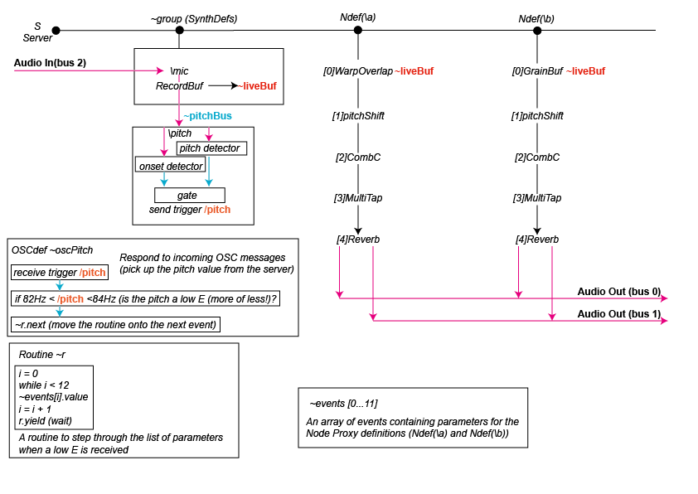
Fig. 16-3: Schematic of an environment created in SuperCollider, which uses a pitch-tracking algorithm to move through an array of pre-composed settings
The sound of the guitar is also used as the source material for the electronic processing so as to frame the natural sound of the instrument with the electronic part. By mapping playing techniques onto the digital environment, causal and mimetic relationships between the acoustic and the electronic can be manipulated and explored in real time, while placing the human agency of the instrumentalist at the centre of any performance. The sound of the acoustic instrument acts as a point of familiarity while interacting with the electronics to enhance, contrast, or subvert expectations.
The SuperCollider environment was not created in isolation but was developed specifically as part of a composition–Latent (2021). The musical material for the composition and the design decisions for the performance environment evolved simultaneously, with each informing and influencing the other. Different paradigms were tested, from a fully notated and structured composition to free improvisation, before a model of controlled improvisation emerged as a suitable environment to exploit the affordances of the system. Two sets of gestures, one from each composer, together with a set of performance notes specifying any boundaries, were created to act as starting points for improvisations. Some examples of the original gestures are shown in Fig. 16-4.
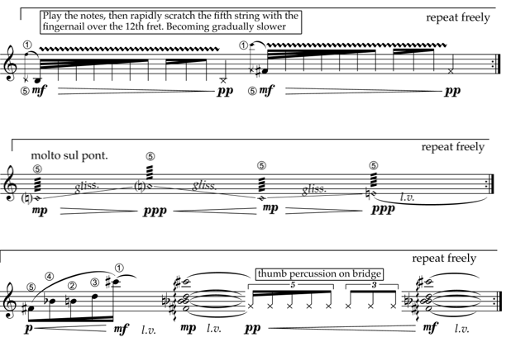

Fig. 16-4: Examples of musical gestures created as starting points for improvisations and to exploit the affordances of the performance environment
The low open E string was chosen as a trigger note for the electronic part. This was partly for pragmatic reasons–it is an easy note to isolate and exploit on the guitar–and partly for aesthetic reasons–the note carries a certain significance for guitarists and as such works well visually on the score. However, any pitch, or a number of pitches, could have been used for triggers. This is an obvious area to develop in future compositions.
Clearly, there are limitations with a system which reserves certain pitches, in conjunction with dynamic thresholds, as control signals. This effectively removes those pitches from any compositional material or improvisation that does not trigger the electronic processing. One possible solution to this would be to include a gate to toggle the control signals on or off. The gate could be timed so that there would be periods in the performance when the control signals would be included or excluded.
Another limitation is the danger of false triggers: harmonic overtones in the input signal being incorrectly recognised and triggering the electronic processing at unexpected moments. False triggers can also arise from processed material in the electronic part bleeding into the input signal of the SuperCollider environment. These false triggers can be minimised, however, by carefully compressing and filtering the input signal while at the same time tailoring the parameters of the pitch-tracking algorithm to specific performances. Despite these limitations it is possible, through careful choice of microphones, microphone placement, speaker positioning, balancing of levels, filtering, and setting up of parameters in the code, to configure the environment to be a highly effective performance space which offers many interesting possibilities and much potential for future work.

The state of collaboration within the new Guitarscape

Numerous organological affordances and extended possibilities of the guitar (Dawe, 2010), alongside the pluralistic nature of its identity in the 21st century (Goss, 2021), have contributed to many of the instrument’s players maintaining a position at the vanguard of both collaborative and electronic musical performance. For example, in 2020, the global coronavirus pandemic provoked national lockdowns around the world, and this in turn motivated a proliferation of remote musical collaborations featuring the guitar. Virtual guitar ensembles and guitar orchestras of all shapes and sizes increased dramatically using an array of digital technologies to connect performers around the world. A pertinent example of this was the Virtual Guitar Orchestra, which connected 200 guitarists (acoustic, bass, classical, electric, and fingerstyle) from 40 countries, in a performance of Scient, Safe and Sane by Sergio Assad (Assad, 2020). However, during these recent and intense periods of remote collaboration, latency has continued to frustrate online collaborative efforts, and prevented some altogether, despite an increasing number of products designed to address the issue. For example, it was necessary for performers within the Virtual Guitar Orchestra to pre-record their individual parts before the musical material was subsequently compiled. However, this is far from “live” musical performance.
The academic and musical collaboration between the present authors was established within a shared educative environment (the Department of Music, Durham University, UK), nurtured in the context of contemporary music festivals (DurhamKLANG and NoiseFloor), and accelerated within a specialist guitar organisation (the International Guitar Research Centre). The collaboration has centred around designing a bespoke digital environment for guitar performance, and exploring the musical possibilities which arise from embracing latency, rather than embarking on a futile endeavour to eliminate it. The endeavour has embodied a manifestation of, both individual and shared, intrinsic motivations (curiosity, enjoyment, interest, self-determination, and task involvement) and extrinsic motivations (evaluation, recognition, and other tangible incentives) (Amabile, Hill, Hennessey, & Tighe, 1994). The nature and trajectory of this partnership is common within the new Guitarscape: collaboration and cross-fertilisation of ideas between afficionados and specialists seeking to extend the possibilities of the instrument is increasingly prevalent.

Latent

In the case of Latent, the electronic environment uses pitch recognition as a trigger for progression through a series of pre-composed events. A non-time-critical score, which works in tandem with the digital environment, allows and encourages interaction between the guitarists and the electronics in “real” time, without concern for the constraints and restrictions of latency.
Throughout the compositional process, the approximate length of each musical gesture was determined in accordance with the nature of the electronics (i.e. purposefully designed to be fragmentary in nature, so that the causal and mimetic relationships between the classical guitars and the electronics could be explored and manipulated in real time). During the evolution of the digital environment and the physical score, it became increasingly apparent that the integrated hybrid system, and the collaboration more generally, were manifestations of the balance between “order” and “chaos”. Whilst both collaborators have shared musical interests (contemporary music performance, electronics, the classical guitar, etc.) and shared environments of professional development (Durham University, the International Guitar Research Centre, etc.), their specific areas of expertise are different. In terms of musical material, Estibeiro favours slightly longer musical gestures, whereas Cotter favours shorter musical gestures. Estibeiro’s gestures were mostly the product of experimentation with the electronic environment in order to assess their efficacy, whereas Cotter preferred borrowing and mediating musical ideas from eminent and innovative composers for the guitar, such as Leo Brouwer and Marc Codina. The score can be considered as understood territory, but the ever-evolving nature of the electronics is forever changing. A national lockdown prevented use of many of the physical tools which would usually expedite performance. However, various software and technologies (Facebook Messenger, Google Drive, OBS, SonoBus, Zoom, etc.) facilitated the remote processes of collaboration, co-composition, and co-performance. A schematic of the system used for remote collaboration is shown in Fig 16-5.

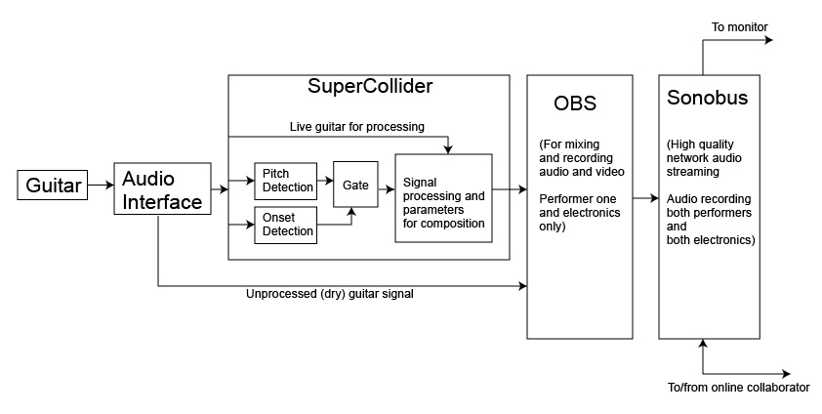
Fig. 16-5: The system used to facilitate remote collaboration

Ultimately, the collaboration was characterised by “a number of levels and degrees of separation, including those of place, time and expertise” (Barrett, 2014). Cotter and Estibeiro mediated “marriages of insufficiency” (Shulman, 2004) by bringing “varied profile[s] of skills, knowledge and expertise to the enterprise” (Barrett, 2014), and this informed the aesthetic considerations behind the construction and design of the score (Fig. 16-6).

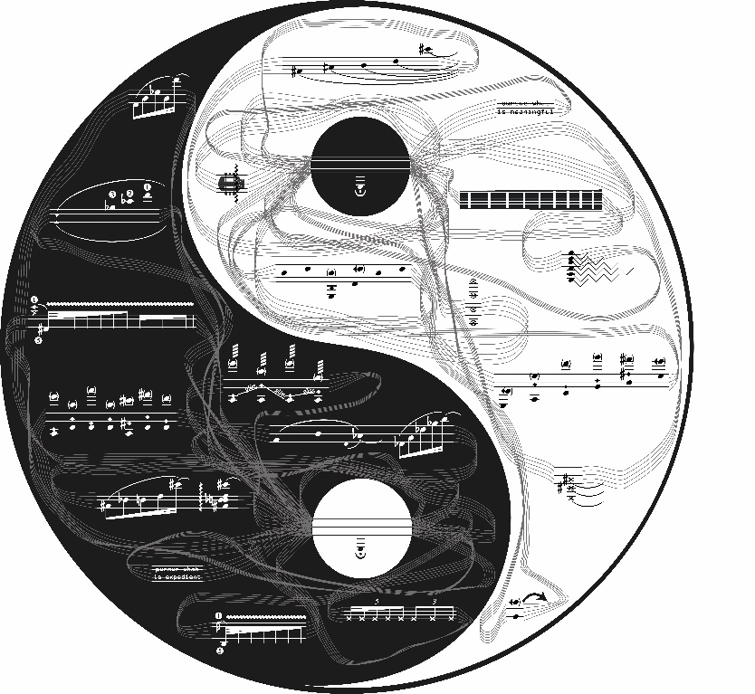
Fig. 16-6: Latent (2021)
As instructed within the performance directions which accompany the score for Latent, player 1 controls yin (the dark half of the score) and player 2 controls yang (the light half of the score). Once the electronic part has been started, each player chooses a musical fragment and begins to play. The musical material may be performed in either a linear or non-linear manner. Thus, the performers are encouraged, at their own discretion, to improvise in and around each fragment. This may include repeating certain notes, repeating certain passages, repeating whole gestures, etc. Each player is afforded the opportunity to improvise and mediate expressive musical parameters (dynamics, pitch, tempo, timbre, etc.) in response to the sound world of their electronics, the actions of their co-performer, the sound world of their co-performer’s electronics, and the sound world of the environment as a whole. The indeterminate nature of both the score as a whole, and the individual musical fragments, serve to encourage engagement with the digital environment. Players are able to easily mediate sonic parameters such as dynamics, pitch, and timbre. Using these as control signals allows the guitarists to exploit their existing virtuosities during live performance.
Players navigate themselves, both musically and visually, towards the circle within their respective side of the score every c.60 seconds. Pitch recognition will detect the plucking of the low E string, and consequently trigger progression through a series of precomposed events. The process of navigating the score and interacting with the co-performer and live electronics continues until all fragments have been played and the digital environment has ended. Latency is to be embraced at all times: aside from facilitating remote co-performance, this encourages each player to focus primarily on the bespoke digital environment.

The pragmatics and processes of remote co-performance within the digital environment

Guitarists interacting with unique electronic performance environments must consider and contend with a large number of performative and pragmatic issues. In the instance of Latent, for example, each guitarist must mediate a physical relationship with their instrument, whilst also monitoring the score, the evolving nature of their electronics, the actions of their co-performer, the evolving nature of their co-performer’s electronics, an audio-visual recording of themselves, and various technological paraphernalia (an audio interface, headphones, etc.). These stimuli, both sonic and visual, may be situated across a unique arrangement of digital screens which surround the guitarist. The omnidirectional feedback loops which exist between two co-performers and their respective electronic environments must be carefully navigated in accordance with the other interfaces, which all require varying levels of attention (see Fig. 16-7). Whilst performing with this bespoke digital environment, the electronics affect the relationship between the co-performers by blurring the causal relationship between each guitarist’s gestures and the sounds produced in the virtual space.
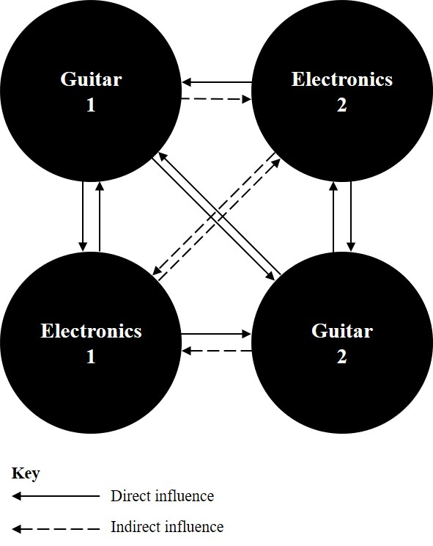
Fig. 16-7: Omnidirectional feedback loops between the acoustic instruments and the electronic environments during live performance

Immediately following the premiere of Latent, Martin Vishnick (guitarist, composer, teacher, and researcher) voiced his surprise at how “musical” the environment was; proving that sustained engagement with a bespoke interface (through composition, rehearsal, and reflexive artistic research) can lead to virtuosic performance. Furthermore, this demonstrates how it is not always necessary for “new” performance practices to be established following interaction with unique and innovative digital environments. Rather, in the instance of a musical work such as Latent, which is characterised by combining the classical guitar with electronics, the ever-evolving performance practices of the “traditional” instrument, the “innovative” interface, and the performance contexts are advanced simultaneously.
The time taken to build bespoke digital environments and become familiar interacting with them is often extensive. Thus, it is important that such models, alongside directions for their use, are codified and disseminated amongst musicians. This prevents the lifespans of such environments from being so ephemeral, and abates the reluctance of performers to abandon existing practices simply to accommodate new modifications. Furthermore, bespoke environments such as Latent are also useful to musicologists more generally, as they constitute propitious vehicles for the interrogation of the collaborative, communicative, and creative processes which occur during live musical performance.

Conclusion

This chapter has explored some of the issues raised when acoustic instruments, particularly the guitar in this instance, are combined with electronic instruments. We have seen that although there is a long history of the use of electronics with the guitar, there is much less material concerning the classical guitar beyond a relatively small but thriving specialist community. This is due to a number of factors, one of which may be that most uses of electronics with the guitar model paradigms of acoustic instruments. The uses of electronics with the classical guitar, however, from the 1960s onwards, have tended to follow paradigms where causal relationships between gesture and sound production have been less clearly defined. By exploring relationships between performers, instruments, and the wider environment, we have seen how instruments influence our aesthetic values and choices. New instruments encourage us to extend these values. Combining the guitar with electronics produces fertile ground for artistic practice as research. We have also seen how bespoke digital instruments do not encourage embodiment relationships to the same extent as acoustic instruments. This is mainly due to the arbitrary mappings between the interface and the sound-producing engine as well as the relatively short lifespans of such instruments. Designing a bespoke environment for the classical guitar which uses the existing skillset of the guitarist to control the electronics is one way to encourage a deeper engagement with the instrument.

Bibliography
Ableton. (2020). About Ableton. Retrieved March 2020, from Ableton: https://www.ableton.com/en/about/
Akai. (2020). MPC Series. Retrieved March 2020, from Akai Professional: https://www.akaipro.com/products/mpc-series
Alperson, P. (2008). The Instrumentality of Music. Journal of Aesthetics and Art Criticism, 66(1), 37-51.
Amabile, T., Hill, K., Hennessey, B., & Tighe, E. (1994). The Work Preference Inventory: Assessing Intrinsic and Extrinsic Motivational Orientations. Journal of Personality and Social Psychology, 66(5), 950-67.
Anderton, C. (n.d.). The History of MIDI. Retrieved March 2020, from MIDI.org: https://www.midi.org/articles/a-brief-history-of-midi
Assad, S. (2020). Scient, Safe and Sane [Recorded by V. G. Orchestra]. Retrieved April 2021, from https://www.youtube.com/watch?v=MXotkK7M1fk
Astley Brown, M. (2015). SynthAxe: back to the future of guitars. Retrieved March 2020, from Music Radad: https://www.musicradar.com/news/guitars/synthaxe-back-to-the-future-of-guitars-629632
Barrett, M. (2014). Collaborative Creativity and Creative Collaboration: Troubling the Creative Imaginary. In M. Barrett (Ed.), Collaborative Creative Thought and Practice in Music (pp. 3-14). Farnham, Surrey, UK: Ashgate Publishing Limited.
Berio, L. (1988). Sequenza XI for Guitar. Universal Edition.
Bordalejo, T. (2020). Hauteurs. Retrieved March 2020, from Tomás Bordalejo, Composer: https://tomasbordalejo.com/portfolio/hauteurs
Brandon, A., & Torres, R. (2020). The 21st Century Guitar; Unconventional Approaches to Performance, Composition and Research. Retrieved March 2020, from The 21st Century Guitar: http://www.21cguitar.com/
Chadabe, J. (2002). The Limitations of Mapping as a Structural Descriptive in Electronic Instruments. Proceedings of the 2002 Conference on New Instruments for Musical Expression (NIME 02) (pp. 38-42). NIME.
Clark, A., & Chambers, D. (1998). The extended mind. Analysis, 58(1), 7 -19.
Cycling 74. (2020). What is Max? Retrieved March 2020, from Cycling '74: https://cycling74.com/
Dawe, K. (2010). The New Guitarscape in Critical Theory, Cultural Practice and Musical Performance. Farnham, Surrey, UK: Ashgate Publishing Limited.
Doati, R. (2020). L'Apparizione di Tre Rughe (2001 - 2004). Retrieved March 2020, from Roberto Doati: http://www.robertodoati.com/index.php?option=com_content&view=article&id=108:lapparizione-di-tre-rughe-2001-2004-guitar-electronics-and-eyesweb-interactive-system-25&catid=23:acoustic-instruments-and-electronics&Itemid=23
Drogoz, P. (1970). Agression, Pièce Pour Guitare 10 Cordes Et Bande Magnétique [Recorded by M. Dintrich]. On Michel Dintrich No 2 La Guitar Au-Delà. CPF Barclay.
Emmerson, S., & Smalley, D. (2001). Electro-acoustic music. Retrieved March 2020, from Grove Music Online: http://www.oxfordmusiconline.com:80/subscriber/article/grove/music/08695
Eventide. (n.d.). H910 Harmonizer. Retrieved March 2020, from Eventide: https://www.eventideaudio.com/products/legacy/h910-harmonizer
Ezaki, K. (1968). Ongaku for Guitar and Electronic Sound. Tokyo: Edicion Casa de la Guitarra.
Gilby, I. (1986, April). Yamaha SPX 90. Sound on Sound. Available from Mu:zines Music Magazine Archive http://www.muzines.co.uk/articles/yamaha-spx90/1392 accessed March 2020.
Good, E. M. (2002). Giraffes, black dragons and other pianos: A technological history from Cristofori to the modern concert grand. Stanford University Press.
Goss, S. (2021, March). Hiraeth: Manuel de Falla, Andrés Segovia, and the politics of nostalgia (Paper). The 21st Century Guitar: Unconventional Approaches to Performance, Composition and Research (Conference).
Guerrero Santos Marques, B. (2020). Repertório para violão e eletrónica: narrativas históricas, representação, permanência e performance. Retrieved March 2020, from Universidade de Aveiro Departamento de Comunicação e Arte Online Depository.
Guitar Player. (1986, June). Special report: guitar synthesisers and MIDI. Guitar Player Magazine. Future Publishing Limited.
Hornbostel, E., & Sachs, C. (1961). Classification of Musical Instruments. Galpin Society Journal, XIV.
Hughes, T. (2014). Echoes of the Past and Future. Retrieved March 2020, from Premier Guitars: https://www.premierguitar.com/articles/21317-echoes-of-the-past-and-future?page=6
Hunter, D. (2005). Guitar Rigs: Classic Guitar and Amp Combinations. Backbest.
Ihde, D. (2007). Technologies - Musics - Embodiments. Janus Head, 10(1), 7-24.
InfoMus. (2020). The EyesWeb Project. Retrieved March 2020, from InfoMus.org: http://www.infomus.org/eyesweb_ita.php
Ingram, A. (2006). A Concise History of the Electric Guitar. Mel Bay.
Ircam. (2020). Retrieved March 2020, from IRCAM: https://www.ircam.fr/
Ircam Centre Pompidou. (n.d.). A Brief History of Max. Retrieved March 2020, from Ircam Free Software Archived available from web.archive.org: http://freesoftware.ircam.fr/article.php3?id_article=5
Kermit-Canfield, E. (2014). A Comparison of Real-Time Pitch Detection Algorithms in SuperCollider. Proceedings of the 137th Audio Engineering Society Convention. Audio Engineering Scoiety.
KVA. (2014). Hero worship: and interview with John Mclaughlin. Retrieved March 2020, from KVA: https://www.kvraudio.com/interviews/hero-worship---an-interview-with-john-mclaughlin-23941
Lachenmann, H. (1977). Salut für Caudwell. Breitkopf & Härtel.
Lash, D. (2011, Winter). Derek Bailey's Practice/Practise. Perspectives of New Music, 49(1), 143-171.
Leman, M. (2007). Embodied music cognition and the mediation of technology. MIT Press.
Lewis, K. (2019). Conference Report: International Guitar Research Centre Conference Hong Kong 2019. Retrieved March 2020, from Kate Lewis Online: https://katelewisonline.com/2019/07/31/international-guitar-research-centre-conference-hong-kong-july-2019/
Lippe, C. (2020). Compositions. Retrieved March 2020, from Cort Lipps: https://www.cortlippe.com/compositions.html
Little, C. (1985, May/June). John McLaughlin and Pat Metheny: Guitar synthesis more or less in the jazz tradition. Jazziz Magazine interview available online from: http://users.cs.cf.ac.uk/Dave.Marshall/mclaughlin/art/synthesists.html Accessed March 2020.
Magnusson, T. (2009). Of Epistemic Tools: Musical Instruments as Cognitive Extensions. Organised Sound, 168-176.
Manning, P. (2013). Electronic and Computer Music (fourth edition). OUP.
MIMO Consortium. (2011, July 8). Revision of the Hornbostel-Sachs Classification of Musical Instruments by the MIMO Consortium. Retrieved March 30, 2021, from Musical Instrument Museums Online: http://www.mimo-international.com/documents/Hornbostel%20Sachs.pdf?_ga=2.222041176.1579797694.1610912234-1020133287.1610912234
Mueller, M. (2019). Retrieved December 2019, from SABRE Music Technology: https://www.sabre-mt.com/sabre-products-2
Musgrave, T. (1969). Soliloquy for Guitar and Tape. Wise Music Classical.
Nijs, L. (2017). The merging of musician and musical instrument: incorporation, presence and the levels of embodiment. In M. Lesaffre, P.-J. Maes, & M. Leman, The Routledge Companion to Music Interaction. Routledge.
NIME. (2020). The International Conference on New Interfaces for Musical Expression. Retrieved March 2020, from NIME: https://www.nime.org/
Paul, L., & Cochran, M. (2016). Les Paul; Centennial Edition; In His Own Words. Applause Theatre Book Publishers.
Pickford, J. (2014). Vintage: Watkins Copycat. Retrieved March 2020, from MusicTech: https://www.musictech.net/reviews/watkins-copicat/
Prior, N. (2008). Putting a glitch in the field: Bordieu, actor network theory and contemporary music. Cultural Sociology, 2(3), 301-319.
Puckette, M. (2002). Max at Seventeen. Computer Music Journal, 26(4), 31-43.
Radbound Reflects. (2018, January 11). How technology changes us; Lecture with Don Ihde and Peter-Paul Verbeek. Retrieved March 2020, from Radbound Reflects YouTube Channel: https://www.youtube.com/watch?v=hmBgJjfjG7Q
Redgate, C. (2017). Composition changing instruments changing composition. In E. Clarke, & M. Doffman (Eds.), Distributed Creativity: Collaboration and Improvisation in Contemporary Music. New York, NY: Oxford University Press.
Rickenbacker. (2020). The Earliest Days of the Electric Guitar. Retrieved March 2020, from Rickenbacker: http://www.rickenbacker.com/history_early.asp
Roland. (2018). Company History. Retrieved March 2020, from Roland: https://www.roland.com/uk/company/history/
Roland. (2020). The TR808 Story. Retrieved March 2020, from Roland: https://www.roland.com/uk/promos/roland_tr-808/
Roli. (2020). Seaboard: the future of the keyboard. Retrieved March 2020, from Roli: https://roli.com/products/seaboard
Shapiro, L. (2010). Embodied Cognition. Routledge.
Sheer Pluck. (n.d.). Retrieved March 2021, from Sheer Pluck: Database of Contemporary Guitar Music: https://www.sheerpluck.de/
Shulman, L. (2004). Just in Case: Reflections on Learning from Experience. In L. Shulman (Ed.), The Wisdom of Practice: Essays on Teaching, Learning and Learning to Teach (pp. 462-82). San Francisco, CA: Jossey-Bass.
Stenson, E. (1984, March). Roland SDE 3000 Digital Delay. Electronics and Music Maker, Available from Mu:zines Music Magazine Archive, http://www.muzines.co.uk/articles/roland-sde-3000-digital-delay/1591, Accessed March 2020.
SuperCollider. (2020). SuperCollider. Retrieved March 2020, from SuperCollider: https://supercollider.github.io/
Tammen, H. (2017). Case Study: The Endangered Guitar. In T. d.-I. Bovermann, Musical Instruments in the 21st Century. Singapore: Springer.
Tennant, S. (1995). Pumping Nylon. New York, NY: Alfred Publishing Co.
The 21st Century Guitar. (2021). The 21st Century Guitar Conference 2021 Programme. Retrieved April 2021, from https://research.unl.pt/ws/portalfiles/portal/28875317/The_21st_Century_Guitar_Conference_2021_Programme.pdf
Thompson, B. (2019). Retrieved November 2019, from BillThompson.org: http://billthompson.org/aka_prof_lofi/
Vortex Music Journal. (2020). Vortex Music Journal, 8(3). Retrieved March 2021, from http://vortex.unespar.edu.br/
Warburton, D. (2001). Keith Rowe; Interview. Retrieved March 2020, from Paris Tansatlantic: http://www.paristransatlantic.com/magazine/interviews/rowe.html
Zatorre, R., Chen, J., & Penhune, V. (2007, July). When the brain plays music; auditory-motor interactions in music perception and production. Nature Reviews Neoroscience, 8(7), 547-558.

